## Presets Script

Table: errortype

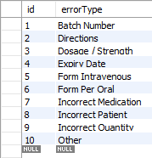

Table: location

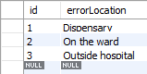

Table: severity

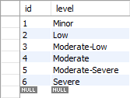

Table: medicationtype

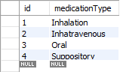

Table: patienttype

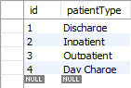

## Test Data Script

Table: error

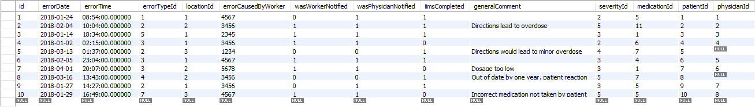

Table: physician

Table: patient

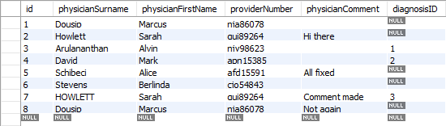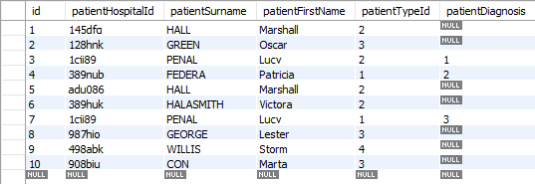

Table: worker

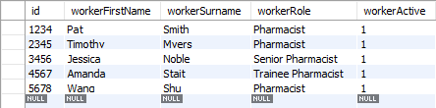

Table: Medication

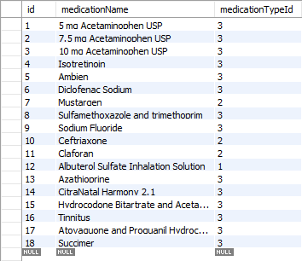

## Test Logins Script

Table: login

